Type an Informative and Concise Paper Title Here
Ciren Wu ^{a,*}, John Fakename ^{b}
ª Department of Environmental Science, World Class University, City, Province 123456, Country
^{b} Animal Science Technology Institute, City, State 54321, Country
* Corresponding author. Email: xyz@nowhere.ss

Abstract
This template is designed to assist editing and printing a high-quality proceedings book. It will also be helpful for preparing papers for the symposium. Please follow the format requirements outlined in the template and use the built-in pre-defined styles. If you have any questions about this template, please contact Dr. Jiqin (J.Q.) Ni (email: jiqin@purdue.edu).
Write a concise and factual abstract in this section. Limit the length of the abstract to less than 250 words. Instructions about how to write abstracts are provided by many reputable scientific journals, for example: “The abstract should state briefly the purpose of the research, the principal results, and major conclusions. An abstract is often presented separately from the article, so it must be able to stand alone. For this reason, references should be avoided, but if essential, then cite the author(s) and year(s). Also, non-standard or uncommon abbreviations should be avoided, but if essential they must be defined at their first mention in the abstract itself”. (http://www.elsevier.com/journals/environmental-pollution/0269-7491/guide-for-authors).
Keywords: Leave the word “Keywords:”, type 5 to 6 keywords or key phrases, and separate them with commas here. You can list both specific and general terms that will aid in searches, but avoid repeating the nouns or phrases in the Title because almost all the nouns in the Title of scientific papers are keywords.

Introduction
The lengths of a research paper and a review paper, including reference lists, for this symposium proceedings are limited to 8 and 10 pages, respectively. Provide an adequate background in this Introduction section to assist readers understand the significance of the research presented in your paper, but avoid a detailed literature survey or a summary of the results. State also the objectives of the work in this section.

Materials and Methods
Provide sufficient details of the materials and methods to allow your work to be reproduced.

Paper and text areas
This template uses A4 size paper (21 cm × 29.7 cm) because the proceedings book will be printed in China. The text area of the template is 12.3 cm × 19 cm to fit in the printed proceedings book of 15.2 cm × 22.7 cm paper size without reduction.

Font and headings
The basic font of this template is 9 pt Times New Roman. Use the “Body Text” style, which has an indent of 0.5 cm, for the paper text (Figure 1). Use the three levels of numbered Headings built in the template to design your paper structure. Please limit the heading levels to three.
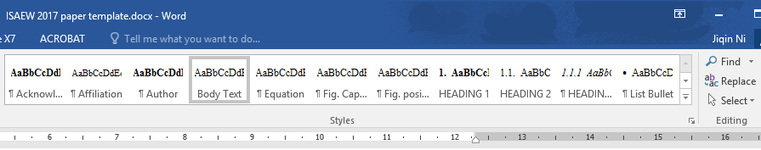
Figure 1. Select and use the built-in styles in this template.

Equations
Do NOT use the MS Word in the tool bar “Insert” – “Equation” (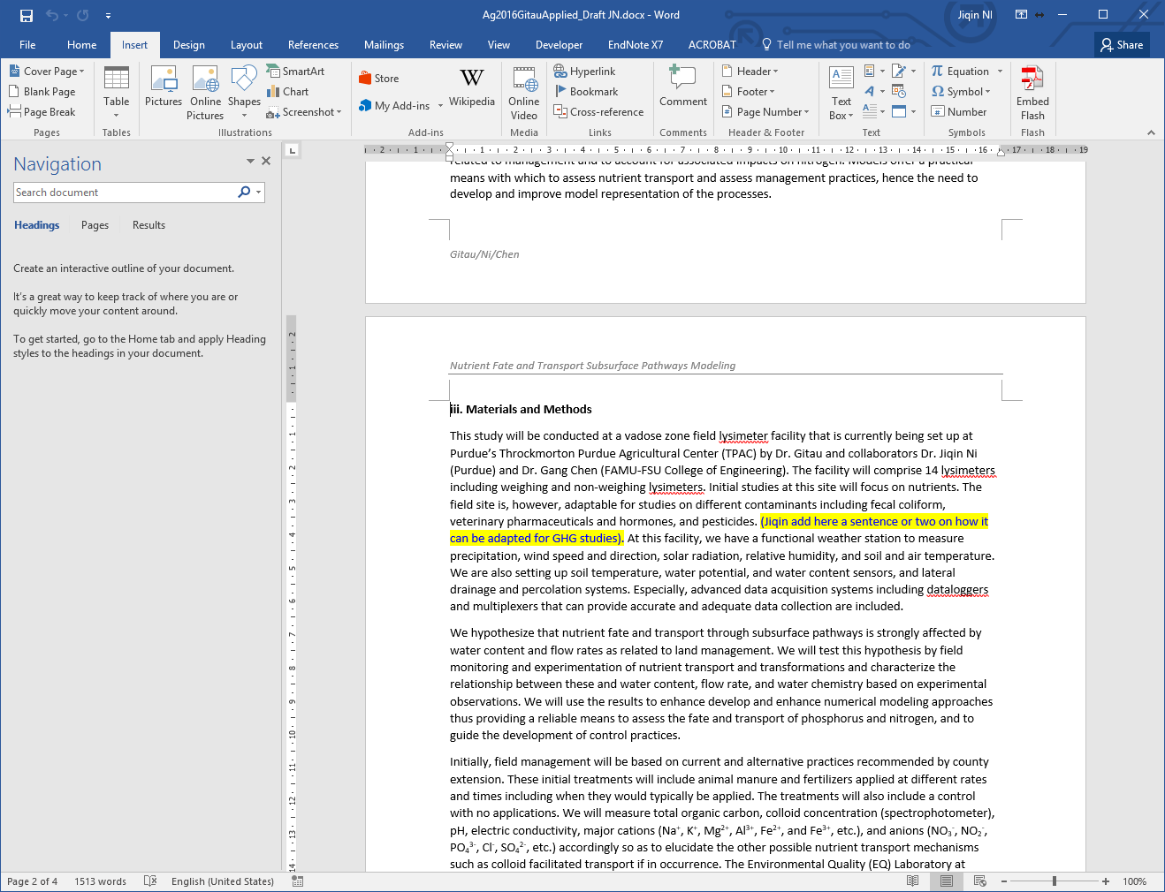) to compse equations.
Instead, use Microsoft Equation 3.0 (a built-in tool in MS Word) or MathType (a software application created by Design Science www.dessci.com) to compose your equations. To insert a MS Equation 3.0 or Math Type, go to menu “Insert” – “Text” group, select “Object” then “Object…”, then select “Microsoft Equation 3.0” or “Math Type”.
An example equation using 9 pt size font is shown here in Eq. (1).
(1)
where E is aerial pollutant emission rate, mass time⁻¹; Q is air exchange rate, volume time⁻¹; C₁ and C₂ are aerial pollutant concentrations at the inlet and outlet of the air exchange space, respectively, mass volumn⁻¹. (Use the no-indent “Normal” style for this “where…” sentence and with the “w” in lower case because this sentence is part of the equation).
More explanation about your equation can start here using the “Body Text” style. If your MS Word has Math Type installed, you can simply copy Eq. (1) in this template, paste it where you need, double-click the equation, and edit it to your equation.
Use the “Equation” style in this template and place one tab before and one tab after the equation (Figure 2).
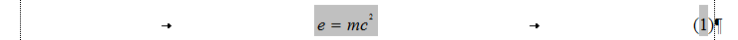
Figure 2. An equation using the “Equation” style with one tab before and one tab after the equation.
To show or hide the tabs and spaces, etc., click the paragraph mark “¶” in Home – Paragraph group.

Results and Discussion
Write in this section what you have obtained from your work and how you interpret them. This section can also be separated into two sections: 3. Results and 4. Discussion.

Figures
The proceedings book requires that all figures be formatted consistently and highly legible. Please read the following suggestions to create high quality printing of figures for your paper.
- Design or resize your figures so that the text in the figures will appear approximately 9 pt Times New Roman font size, which is the size of Body Text in the paper.
- Format the Layout of figures using “In line with Text.” Do not have floating figures unless it is needed for typesetting purpose.
- Color will be shown in the e-version only, but not in the printed Proceedings. Please test your color figures by printing them in paper in black and white and make sure that they are legible.
- Figures will not be reduced in printing. Limit their maximum width to 12.3 cm.

Photos and scanned images
For digital photos, use 300-dpi resolution. If you use a scan, please select 600 dpi for line art and 300 dpi for grayscale and photos.

Drawings and charts
If you copy a drawing or chart from Excel, Power Point, or other software, paste it in this Word template file using “Paste” – “Paste Special…”, then select “Picture (Enhanced Metafile)” to keep the maximum clarity and make it easily resizable (Figure 3). Use the “Fig. Position” style for the figure and the “Fig. Caption” for the figure caption.
Figure 3. An example of a chart from MS Excel pasted here using “Paste Special” – “Picture (Enhanced Metafile)”.

Tables
Use the “Table Caption” style for the caption and “Table Contents” style for the table.
Avoid tables with too many columns. A table should usually be designed to have more rows than columns.
Do not paste the table as a picture. Leave the table editable for editors to reformat when it is necessary (Table 1).
Table 1. An example table: registration fees of 2017 ISAEW, Chongqing, China.
Attendee Category * | Early Registration  by June 10, 2017 | Regular Registration  by August 31, 2017 | On-site  Registration
Overseas – Regular | $320 | $360 | $400
Domestic - Regular | ¥1800 | ¥2000 | ¥2200
Overseas – Students | $160 | $180 | $200
Domestic – Students | ¥900 | ¥1000 | ¥1000
*Registration fee will cover the symposium and meals. Lodging expenses are the responsibility of the attendees.

In-text citations
The author-year style should be used for in-text reference citations.
For single author references, use the author’s name (without initials, unless there is ambiguity) and the year of publication.
More than one reference from the same author(s) in the same year must be identified by the letters “a”, “b”, “c”, etc., placed after the year of publication, e.g., (Smith, 1996a, 1996b, 1999).
For two-author references, use both authors’ names and the year of publication, e.g., (Wang and Jones, 2013).
For references with three or more authors, use the first author’s name followed by “et al.,” and the year of publication, e.g., (James et al., 2016).
Citations may be made parenthetically or directly, e.g., “…as already demonstrated in several publications (Smith, 1996a, 1996b, 1999; Wang and Jones, 2013; James et al., 2016). Recently, Liu et al. (2014) have also shown that...”.

English spelling and language editing
As an international symposium, you are free to select either American English or British English spelling in your paper, but do not use mixed spelling in the same paper.
Ensure that your work is written in correct scientific English before submission. Professional language editing services are available, for example:
http://www.aje.com/us/
http://webshop.elsevier.com/languageservices/languageediting/
However, these services are provided by outside vendors and are not endorsed by the ISAEW 2017.

Units and numbers
The SI (metric) units and SI derived units should be used. More information about these units can be found in http://physics.nist.gov/cuu/Units/units.html.
If other units (e.g., U.S. Customary units) are necessary, they should be provided in parentheses.
Express the SI derived units or other units in exponent form with spaces between the elements of the derived unit, e.g., 1.5 kg d⁻¹ and 0.3 g m⁻² d⁻¹.
Use a comma for five-digit and larger numbers, e.g., 10,000 kg (not 10000 kg).

Conclusions
The “Conclusions” section is for you to present your research findings. Do not write what you did or how you did in the research, such as “The nursery pig health as affected by high ammonia concentrations was studied using two advanced respiratory chambers”, because these are your materials and methods used in the research, not conclusions that you drew from the research.
Occasionally, some authors like to give the reader a brief overview of the study, similar to an abstract, in this section. If this is your preference, then change the section heading to “Summary”, but do not simply copy the sentences from the “Abstract”. If the length of presenting your research findings in the Summary is close to half of the total length of this section, the heading “Summary and Conclusions” can be used.
Acknowledgements
Acknowledgements, if any, can be placed here.

References
Please do not exceed 30 cited references for a research paper. For a review paper, this number can be doubled. Make sure that all the cited references are listed here and all the listed references are cited in the paper. Using of publication DOI is encouraged.
References should be arranged alphabetically and then sorted chronologically if necessary.
For EndNote users, an EndNote style file for the ISAEW 2017 papers will be sent to you by contacting Dr. Jiqin (J.Q.) Ni (Email: jiqin@purdue.edu).
Select the “RefListing” in the built-in styles to format the reference list. The following reference arrangements should be used:
Journal articles:
Xin, H., R.S. Gates, A.R. Green, F.M. Mitloehner, P.A. Moore, C.M. Wathes, 2011. Environmental impacts and sustainability of egg production systems. Poultry Science. 90 (1), 263-277. http://dx.doi.org/10.3382/ps.2010-00877.
Books:
Waldau, P., 2010. Animal Rights: What Everyone Needs to Know. Oxford: Oxford University Press. 220 p.
Technical reports:
Forbes, E.G.A., D.L. Easson, V.B. Woods, and Z. McKervey, 2006. An evaluation of manure treatment systems designed to improve nutrient management - A report to the expert group on alternative use of manures. Occasional publication No. 5. Global Research Unit, AFBI Hillsborough, Down, Northern Ireland. May.
Conference proceedings papers and book sections:
Janni, K.A., L.D. Jacobson, R.E. Nicolai, B. Hetchler, and V.J. Johnson, 2005. Airflow reduction of large belt-driven exhaust ventilation fans with shutters and loose belts. In Seventh International Livestock Environment Symposium. Beijing, China, May 18-20. St. Joseph, Mich.: ASAE. Eds., T. Brown-Brandl and R. Maghirang. 245-251.
Theses and dissertations:
Huo, C., 2011. Analysis and Assessment of Nutrients and Physiological Activity Components in Anaerobic Digestion Effluent of Livestock Farm. MS Thesis, College of Engineering, China Agricultural University, Beijing, China.
Internet resources:
IRCAEW, 2011. Constitution of International Research Center for Animal Environment and Welfare. http://www.ircaew.org/Introduction/2013-08-06/1450.html. Accessed March 1, 2015.

This template was last updated on May 5, 2017

© Jiqin Ni, 2015

This template was created for the International Research Center for Animal Environment and Welfare (IRCAEW). Written consent is required for other organizations to use this template.
Contact: Dr. Jiqin (J.Q.) Ni (Email: jiqin@purdue.edu)

