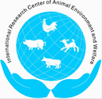 |  | 2019 International Symposium on Animal Environment and Welfare  Chongqing, China•October 21–24, 2019 |  | 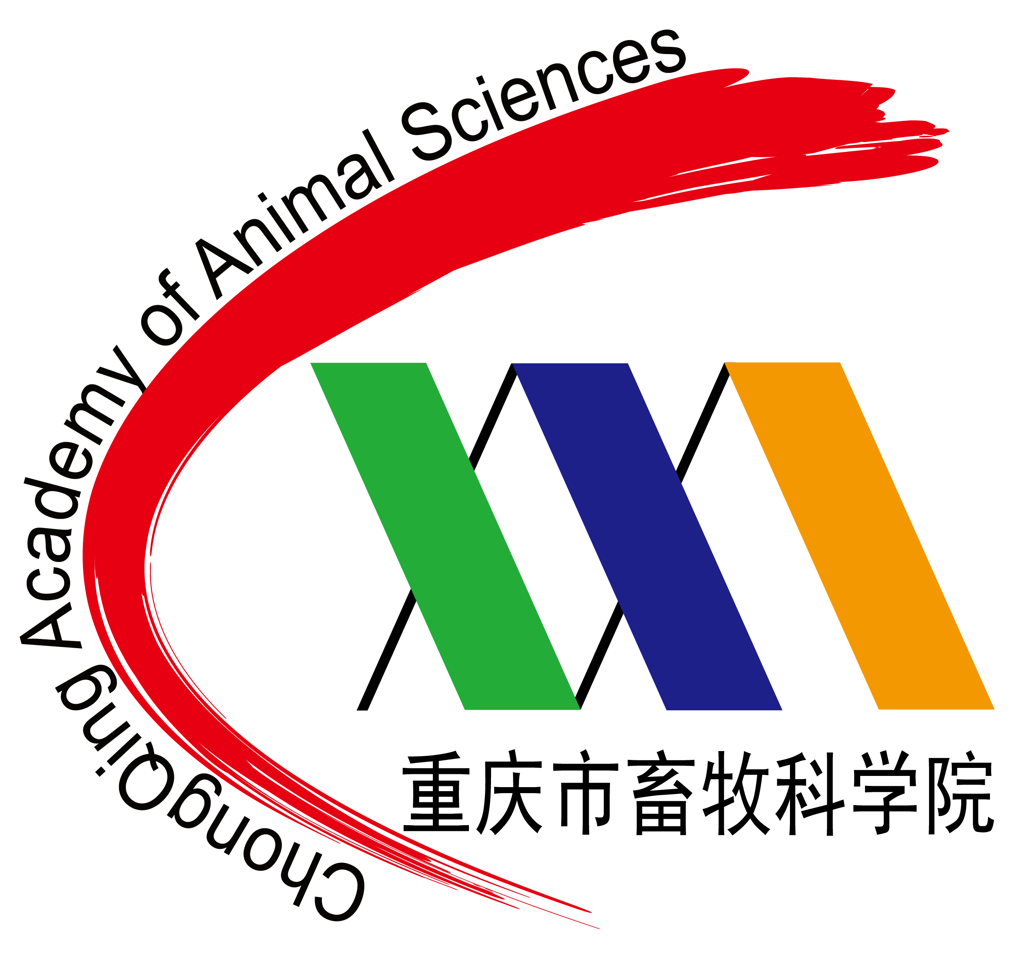

Announcement and Call for Papers and Posters
A healthy environment for occupants and ecosystems and enhanced animal welfare continues to be critical pillars of sustainable modern food animal agriculture globally. The International Research Center for Animal Environment and Welfare (IRCAEW) regularly hosts this biennial symposium to exchange cutting–edge research findings, present and future industry needs and extension materials and methods to further consolidate interdisciplinary endeavors globally, and consequently to advance the science and technology toward improving animal welfare/health, production efficiency, and environmental stewardship. The 2019 International Symposium on Animal Environment and Welfare (ISAEW2019) is scheduled to be held on October 21–24, 2019 in Rongchang District, Chongqing, China. The symposium will provide an international platform for information exchange and network-building among academia, animal industry, government agencies, and technical consultants or serve providers. The ISAEW2019 is calling for papers and posters for the event.
Dates: October 21–24, 2019
October 21, Monday
Onsite Registration
October 22, Tuesday
Morning: Opening Ceremony of ISEAW2019, General session with invited speakers
Afternoon: Concurrent technical sessions
October 23, Wednesday
Morning: General session with invited speakers
Afternoon: Concurrent technical sessions
October 24, Thursday
Morning: General session with invited speakers
Afternoon: Departure
Theme Areas:
The symposium will focus on the following theme areas (in no particular order):
- Biosecurity and Management to Minimize Herd/Flock Health Risks
- Animal diseases and environmental conditions
- Current biosecurity practices in different countries
- Environment-friendly disposal of animal mortalities
- Humane euthanasia and swift mass depopulation of infected animals
- Managing disease outbreaks
- Environmental Monitoring, Assessment and Control
- Heat and moisture production rates
- Heat stress abatement
- Indoor air quality
- Gaseous & PM emissions, fate and transport, and abatement
- Innovative ventilation system designs for improved energy efficiency and animal well-being
- Real-time sensors for enhanced environmental control
- Thermal indexes for modern animals and production systems
- Lighting for optimal animal behavior and performance
- Impacts of Production Systems or Management Practices on
- Animal behavior and well-being
- Consumer’s demand and acceptance (willingness to pay)
- Economic efficiency (cost of production, producer’s profitability)
- Environmental impact (indoor air quality and air emissions)
- Labor requirement
- Product safety and quality;
- Food safety, traceability, and risk management
- Production performance
- All of above
- Manure/Litter Management and Utilization
- Advances in manure treatment technologies (anaerobic digestion, composting, solid-liquid separation, etc.)
- Alternative manure/litter utilization
- Control of odor and gaseous emissions from manure/litter
- Manure land application, and nutrient management planning and regulations
- Precision Livestock Farming
- Animal responses to environmental stimuli for precision management
- Big data, machine learning, and IoT for PLF applications
- Case studies of PLF applications
- Real-time monitoring of animal behaviors for early health warning
- Relationship between behaviors and well-being status of farm animals
- Relationship between behavioral and physiological responses of farm animals
- Sensors, sensing and robotics for PLF applications
- On-farm automation
- Production Systems and Equipment
- Alternative housing systems and performance
- Space requirements of animals for optimal welfare and system design
- New, innovative housing, ventilation and husbandry equipment

Venue: Rongchang District, Chongqing, China
Timeline:
Deadline for abstract submission: March 31, 2019
Notification of abstract acceptance: April 20, 2019
Deadline for initial full paper submission: June 30, 2019
Reviews back to corresponding author: August 1, 2019
Deadline for full paper to be included in the symposium proceedings: September 1, 2019
Registration:
1. Registration: 1) online, please visit http://www.ircaew.org
2) via email, please send the attached WORD registration form to: 1127980958@qq.com
The email subject should be: ISAEW2019 registration + full name
2. Registration Fee:
Attendee Category | Early Registration  by June10, 2019 | Regular Registration  by August 31, 2019 | On-site  Registration
Overseas – Regular | N/A* | N/A* | $400
Domestic - Regular | ¥1,800 | ¥2,000 | ¥2,200
Overseas – Students | N/A* | N/A* | $200
Domestic – Students | ¥900 | ¥1,000 | ¥1,100
*Currently not available, but working on the option of on-line credit card payment, and will update once the service becomes available. Please prepare to pay cash for on-site registration.
3. Registration fee will cover symposium & meals. Lodging expenses are the responsibility of the attendees.
4. To ensure accommodation at the symposium headquarters hotel, the attached registration form (with payment for domestic attendees) must be received by August 31, 2019.
Call for Papers/Posters:
The ISAEW2019 is soliciting papers and posters on the afore-listed topics. To submit a paper or poster, please prepare an abstract of less than 300 words using the attached submission form. Submit the completed form via email to Dr. Lingjuan Wang-Li (lwang5@ncsu.edu).

All abstracts will be lightly reviewed. Presenters of abstracts selected for presentation will be provided with paper and/or poster templates for their finished work. Full-length papers will be edited and published in a symposium proceedings.
Posters are to be vertically oriented and should fit within a 120 cm high x 86 cm wide (47" x 34") area.
Travel and Housing：
The code of Jiangbei Airport in Chongqing is CKG; and convenient domestic flights to Chongqing are available. High speed train (Chongqing Bei—Rongchang Bei) and bus transportation from Jiangbei Airport to Rongchang will be available.
Rongchang Ruier Hotel, a four-star hotel in Rongchang District, will be the headquarters hotel for the symposium.
Sponsored by:
International Research Center for Animal Environment and Welfare
Chinese Society of Agricultural Engineering
China Agricultural University (CAU)
Hosted by:
Chongqing Academy of Animal Sciences (CAAS)
Key Lab of Agricultural Engineering in Structure and Environment, MOA, China
Symposium Co-chairs:
Dr. Baoming LI, Professor, CAU, China
Dr. Hongwei XIN, Distinguished & Endowed Professor, Iowa State University, Director of Egg Industry Center, USA
Program Co-Chairs:
Dr. Lingying ZHAO, Professor, The Ohio State University, USA
Dr. Ruqian ZHAO, Professor, Nanjing Agricultural University, China
Proceedings Co-chairs:
Dr. Lingjuan Wang-Li, Professor, North Carolina State University, USA
Dr. Chaoyuan WANG, Professor, CAU, China
Organizing Committee:
Chair: Dr. Zuohua LIU, Professor and President, CAAS, China
Members: Dr. Yong Huang, Professor, CAAS, China
Dr. Chaoyuan WANG, Professor, CAU, China
Dr. Feiyun Yang, Professor, CAAS, China
Ms. Wen LIU, Associate Professor, CAAS, China
Dr. Weichao ZHENG, Associate Professor, CAU, China
Dr. Hao LI, Associate Professor, CAU, China
Dr. Qin TONG, Assistant Professor, CAU, China
Dr. Chao ZONG, Assistant Professor, CAU, China

For further information or questions, please contact:
Dr. Weichao ZHENG
Department of Agricultural Structure and Bioenvironmental Engineering
China Agricultural University, Mail Box 67, Beijing 100083, China
Cell: +86 13811997928; Fax: +86 10 62736904
Email: weichaozheng@cau.edu.cn
2019 International Symposium on Animal Environment and Welfare
Chongqing, China•October 21–24, 2019

ABSTRACT SUBMISSION FORM (Due March 31, 2019)

Theme Area no. & Topic:
Paper/Poster title:

Author names:
Presentation Type: Oral Poster No preference
First author (if not Corresponding author) E-mail:
Corresponding author E-mail (req’d):
First Name: Surname: Title:
Institutional Affiliation:
Street Address:
City: State/Province:
Zip/Postal Code: Country: Phone:
Abstract (<300 words):

Submit the completed form to Dr. Lingjuan Wang-Li. Email: lwang5@ncsu.edu
Note: The email subject should be: ISAEW2019 abstract + Last name, first name of the first author + abstract number (if the same author has multiple abstracts). For example:
Subject: ISAEW2019 abstract Zhang, Dawen 2
2019 International Symposium on Animal Environment and Welfare
Chongqing, China•October 21–24, 2019

Registration Form
Please type or print clearly
First Name: Surname: Title:
Institutional Affiliation:
Street Address:
City: State/Province:
Zip/Postal Code: Country:
Phone: Fax: E-mail:
Date to arrive: Date to depart:
Special Note:

Return the completed form by faxing or through e-mail by June 10 (early registration), or August 31 (regular registration), 2019 to
Ms. Wen LIU at:
Email: 1127980958@qq.com

